Discovery Form
Company:
Place of registration:
Founding date:
Sector:
Dependencies with other companies:

Your Value Added
Imagine you meet someone who is in a rush in an elevator, who you know you would be interested in working with. You have roughly 30 seconds to describe your business to him, what would you say? (aim to write a maximum of 4 sentences to describe your business)

Who do you think your ideal customer would be? Why?

What do you think the unmet needs or problems faced by your ideal customers are? Do you have any data to support this? (e.g. statistics, conversations with these customers)

How does your business/product/service address these problems or unmet needs?
What makes your business/product/service unique? For example, what is the unique or killer feature that distinguishes you from the competition?

Ownership & Business Summary
Intellectual property
Revenue model

Market background (size, competition, competitive advantage)

Team size
Technology
Technical due diligence
Intellectual property

Financials
Revenue 2020
Forecasted revenue 2021

Expansion Strategy
- Level of intended commercial +/or operational engagement in Europe 2020-2022
- Global expansion plans
- Key Global commercial activity 2020

Your Story

Your Business Model Canvas (please use the input fields given below, do not use canvas itself)

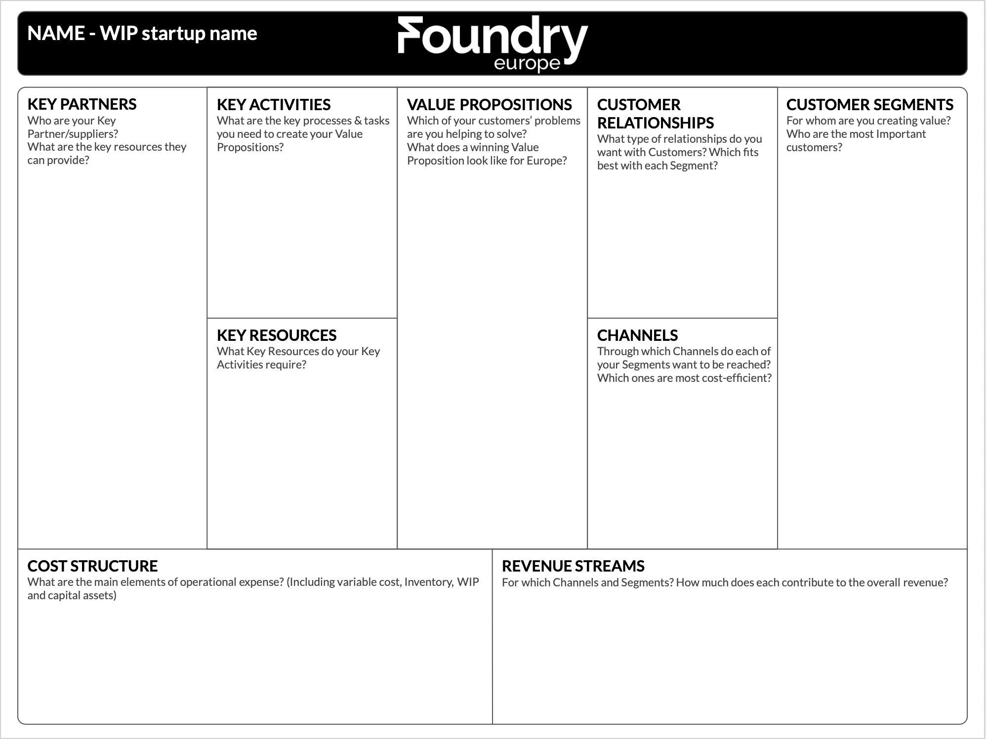

To the best of your ability and based on what you now know or already plan please fill out the standard Business Model Canvas. Don’t worry if you don’t yet have answers for Europe. We’ll fill in those gaps.

Help for filling out the Business Model Canvas:
https://founderco.org/blog/how-to-use-the-business-model-canvas-examples

KEY PARTNERS
Who are your Key Partners/suppliers?
What are the key resources they can provide?
KEY ACTIVITIES CURRENTLY
What are the key processes & tasks you need to create your Value Proposition?
KEY RESOURCES
What Key Resources do your Key Activities require?
VALUE PROPOSITIONS
Which of your customers’ problems are you helping to solve?
What does a winning Value Proposition look like versus today?
CUSTOMER RELATIONSHIPS
What type of relationship(s) do you want with Customers?
Which fits best with each segment?
CHANNELS
Through which Channels do each of your Segments want to be reached?
Which ones are the most cost-efficient?
CUSTOMER SEGMENTS
For whom are you creating value? Who are the most Important customers?
COST STRUCTURE
What are the main elements of operational expense?
(Including variable cost, Inventory, WIP and capital assets)
REVENUE STREAMS
For which Channels and Segments?
How much does each contribute to the overall revenue?

